CONFIDENTIAL
Tiger Mart
ABC Investments LLC
Cheapest Gasoline and Freshest coffee 24 Hours a Day...Our Pledge To You
Business Plan
Prepared September 2013
Contact Information
abc@att.net
251-251-1212
10090 S. Ann Street
Mobile, AL 36603

Table of Contents
Executive Summary 1
Who We Are 1
What We Sell 1
Who We Sell To 2
Financial Summary 2
Company 3
Company Overview 3
Company History 3
Management Team 4
Products and Services 5
Products and Services 5
Competitors 5
Target Market 7
Market Overview 7
Market Needs 7
Strategy and Implementation 8
Marketing Plan 8
Milestones 10
Financial Plan 11
Sales Forecast 11
Personnel Plan 13
Budget 14
Profit and Loss Statement 15
Appendix 18
Sales Forecast 18
Personnel Plan 20
Budget 21
Profit and Loss Statement 23

Executive Summary

Who We Are
John Doe the CEO of this entity is a very capable person and a veteran in this industry. He started in this field with a national chain Speedy. He worked for Speedy as an area supervisor for 8 years and left them in 2000 to start his own venture in this business. To this date he successfully operated/sold 8 stores.
John Smith started into grocery/C-store right after college as his family owned and operated a store in Miami, FL. He has been successfully operating 2 stores for last 14 years.

Start Up Summery
The store we are looking to purchase is an existing Tiger Mart location located at 1099 S. Ann Street, Mobile, AL 36603. The price of this location is $350,000 + Inventory at cost at the day of closing. We put an earnest money deposit of $25,000.
We will put a down payment of additional $50,000 towards the loan. We would like a commercial loan with preferably fixed low interest rate for around 7-9 years amortization.

Objectives

• to capture an increasing share of the local and commuter traffic passing through Broad Street
• To offer our customers superior products, at an affordable price.
• To provide customer service that is second to none.

Financial Summary

Financial Highlights

Financial Highlights by Year

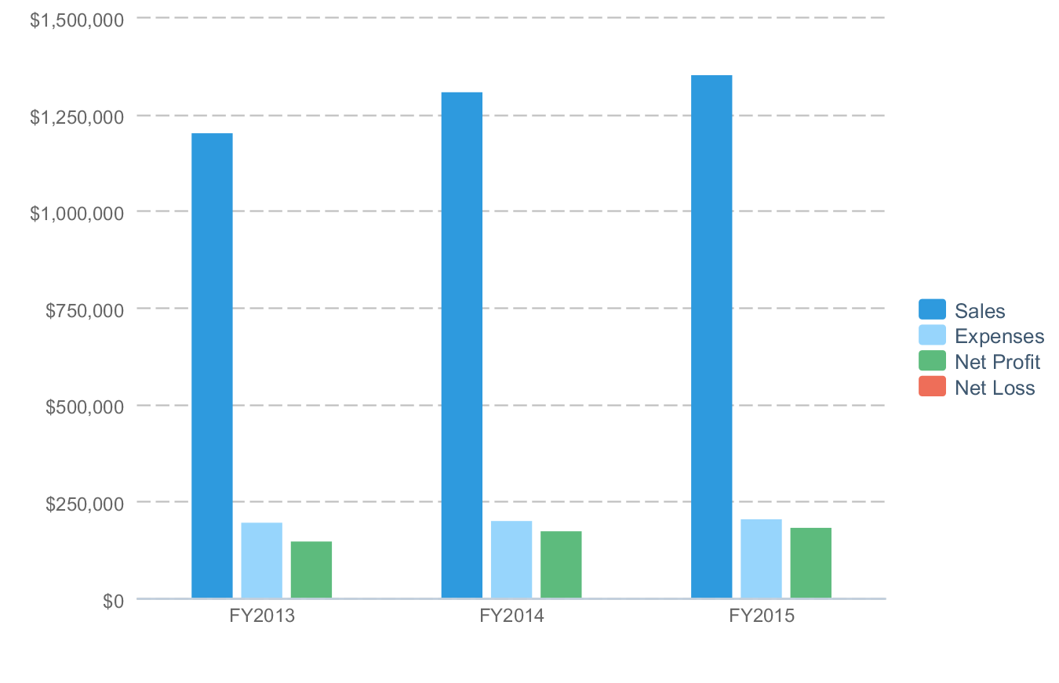

Company

Company Overview
ABC Investments LLC was established in August 2012 to manage and operate gasoline service stations in Mobile, Alabama. In August 2012 it has successfully acquired and operating a Shell Oil location at 31111 North Street, Mobile, AL 36601.
John Doe and John Smith are the founder and owner of this limited liability entity both of whom have years of experience in owning and operating gasoline service/convenience store businesses. Combined they have over 30 years of experience in this industry.
The store will be managed and directed by John Doe with seventeen years experience in gas/C-store operation and J. Smith, an experienced retail food-grocery store operator. John Doe will serve as the company's CEO and John Smith as the company's COO. ABC Investments LLC is established as a limited liability company with 50% ownership by John Doe and 50% ownership by John Smith. The partners will share in management responsibilities with final decisions falling to John Doe where there are differences of opinion. The partnership agreement allows for one partner to buy out the other in the case that the partnership must be dissolved and sets predetermined methods to determine the company's valuation in that case.

Company History
This operating plan is for the Tiger Mart store located at 10999 S Ann Street, Mobile, Alabama 36603, Ann Street is part of Mobile’s historic downtown and on the path of the beautiful yearly Mardi Gras parade route. This store has very steady sales figures over the years and there are no other such stores in 2 mile radius. This store also is surrounded by one of the largest government subsidized housing project of Mobile city.

Management Team
This Tiger Mart facility is a 24 hours store, it will require 7-8 hourly cashier/personnel and 2 supervisors. John Doe will be the acting store manager and we will be supported by one assistant manager. The marketing, finance and banking will be taken care of by John Smith.
The accounting and book keeping will be done by James John CPA PC and all the electronics, video and equipments will be monitored and serviced by Info Tech of Mobile Co. All maintenance on tanks, pumps and all gasoline related instruments will be maintained by NNC pump Services. The payroll service will be provided by ALM staff leasing Co.

Products and Services

Products and Services
Below is a description of the products offered by our gas station
Gasoline Sales
We expects to sell more than 350,000 gallons of fuel per year to motorists within the target market area. This is by far the largest revenue center for the business, but it does not generate an overwhelming amount of profit. The Company will use the gas sales as a primary vehicle for bringing people into the convenience store.
Food, Beverage, Merchandise Sales
The primary profit center of the Gas Station will be the retail sale of packaged food items, prepared food items, beverages (sodas, coffees, and bottled beverages), as well as other merchandise such as small toiletries, ancillary automotive merchandise (oil, fluids, ice scrapers, air fresheners, etc). The Company will offer an expansive number of these items throughout the location.

Competitors
There is no immediate competition to our store. The nearest gasoline station is 2.2 miles away on the corner of Brown St and I-10. In gasoline/grocery business anything over 1.5 miles is considered a non competition as people do not drive 2 miles to buy a pack of cigarette or for a gallon of milk. The store is surrounded by low to low middle class neighborhood which is an ideal market for C-store business and the strong sales figures provided by Tiger Mart proves that theory.

Competition 1 - Chevron:
Chevron is considered a branded gasoline store where their wholesale fuel cost on average 2-3 cents more per gallon at wholesale level than the unbranded gasoline that we will sell at this location. This puts us at a much greater competitive advantage over the Chevron station.

Target Market

Market Overview
Our store's existing customers are divided into two groups as shown in the market analysis for zip code 36603
Group 1: 12,686 people who resides in 4804 homes in 36606 zip code they are our local and immediate customers. The median income is $12,366. 76% of our customers are in construction, transportation, and service oriented business.
Group 2: This group consists of all the downtown travelers and workers that travel on Ann street, a conservative estimate is around 22% of daily business does come from these travelers who like this store for its unique location as it sitting next door to the only McDonald's in 5 mile radius.

Market Needs
Our market is made up of consumers who have busy schedules, a desire for quality, convenience, and disposable income. They like a clean fully stocked gas/convenience store where they can find cheaper gasoline compare to our competitors, reasonably priced beer, drinks milk and other food items and friendly staff. They prefer a store that they can buy a gallon of milk even at 3AM as we are open 24 hours.

Strategy and Implementation

Marketing Plan

Overview
Our marketing strategy is a simple one: satisfied customers are our best marketing tool. When a customer leaves our business after purchasing a product, they know that they got the best price and service money can buy, our name and service will stand on its own via our cheaper process and very competitive gas prices.
In retail gasoline business the best advertising is the price pole sign that we have in the corner of our property, It has the power and ability to draw many hundreds of people a day into the store.
We intent to be very competitive and post at least 2 cents lower price on gasoline than our nearest Chevron branded competitor which will draw enough of the travelers and locals into our store.
We also will run two cycles of promotions one in the summer where we promote fountain drinks which has proven to be very successful in our industry. In winter we will promote our hot beverages like coffee and such.

Competitive Positioning
For local residents of 36603 who give us almost 80% of our daily business, we are the most visible and centrally located on Ann Street. We offer all the products an ideal station should carry at a very competitive price.

Pricing
Gasoline:
We will price our fuel at a cost plus pennies strategy and adjust it in every gas load delivered. All while keeping our competitor's price in mind.
Grocery:
We generally divide the C-store in 6 major categories and the profit margins are usually as:
1. Cigarette at 22%
2. Beer/Wine at 25%
3. Tobacco at 32%
4. Soft drinks at 35%
5. Grocery at 37%
6. Automotive/oil at 40%
The average yearly gasoline margin historically has been around 9 cents/ Gallon. The average C-store profit margin has been around 32%.

Promotion
As mentioned in the Overview we intent to be very competitive and plan to do the following seasonal promotions for our store.
* Buy a "Fill up" 8 Gallons or more and get a Free bag of Popcorn
* Buy any 3 pack of Cigarettes and get a free lighter
* Buy any size Fountain drinks for 89 cents (Summer time)
* Buy any size of our Gourmet coffee for 79 cents (Winter time)
* Buy any 2 liter coca cola or Pepsi for 99 cents (Limited time offer)
* Buy a combo Hot dog and any fountain drinks for only $1.59
There will be many more vendor provided promotions year around.

Financial Plan

Sales Forecast

Sales Forecast
 | FY2013 | FY2014 | FY2015
Sales
Gasoline | $0 | $0 | $0
C-Store | $1,204,000 | $1,310,000 | $1,350,000
Total Sales | $1,204,000 | $1,310,000 | $1,350,000
Direct Cost
Gasoline | $0 | $0 | $0
C-Store | $830,760 | $903,900 | $931,500
Total Direct Cost | $830,760 | $903,900 | $931,500
Gross Margin | $373,240 | $406,100 | $418,500
Gross Margin % | 31% | 31% | 31%

Sales by Month
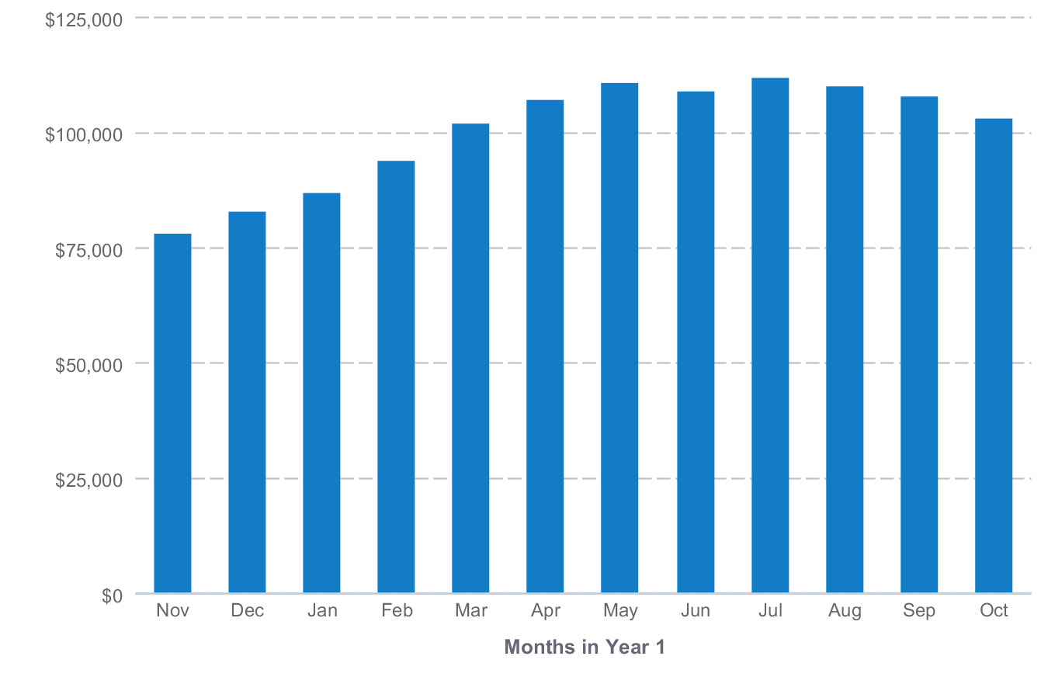

About the Sales Forecast
The gasoline sales forecast represents past historic data that Tiger Mart provided us. We showed a very modest and minimal growth in next two years as the economy is still on a slow recovery, we anticipate this growth via our competitive pricing and better overall customer satisfaction. Personnel Plan

Personnel Table
 | FY2013 | FY2014 | FY2015
Store Manager | $31,000 | $31,620 | $32,252
Hourly Employee | $16,128 | $16,608 | $17,112
Hourly Employee | $16,080 | $16,404 | $16,728
Hourly Employee | $16,080 | $16,404 | $16,728
Hourly Employee | $19,800 | $20,196 | $20,604
Total | $99,088 | $101,232 | $103,424

About the Personnel Plan
This store will have one full time store manager and 7-8 hourly employees. The store is open 24 hours a day 365 days a year. So the store requires around the clock coverage. We forecast a weekly labor budget to be around $2250 before taxes.

Budget

Budget Table
 | FY2013 | FY2014 | FY2015
Expenses
Salary | $99,088 | $101,232 | $103,424
Employee Related Expenses | $11,892 | $12,146 | $12,402
Marketing & Promotion | $9,000 | $9,000 | $9,000
Mortgage | $36,000 | $36,000 | $36,000
Utilities | $33,600 | $33,600 | $33,600
Office Supplies | $900 | $900 | $900
Insurance | $7,800 | $7,800 | $7,800
Total Expenses | $198,280 | $200,678 | $203,126

Expenses by Month
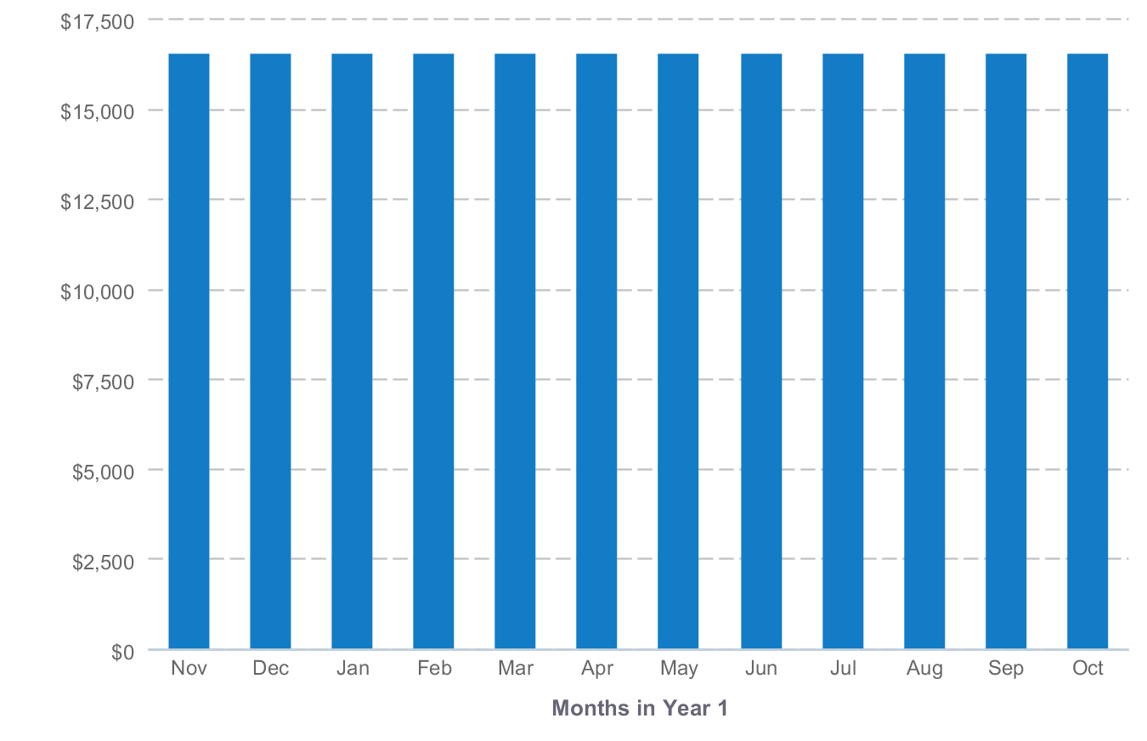

About the Budget
The Mortgage payment is based on a loan for $300,000. Insurance is based on similar payments for other stores we have operated. The utility and other expenses are all averaged yearly than divided into monthly payments.

Profit and Loss Statement

Profit and Loss Statement
 | FY2013 | FY2014 | FY2015
Revenue | $1,204,000 | $1,310,000 | $1,350,000
Direct Cost | $830,760 | $903,900 | $931,500
Gross Margin | $373,240 | $406,100 | $418,500
Gross Margin % | 31% | 31% | 31%
Expenses
Salary | $99,088 | $101,232 | $103,424
Employee Related Expenses | $11,892 | $12,146 | $12,402
Marketing & Promotion | $9,000 | $9,000 | $9,000
Mortgage | $36,000 | $36,000 | $36,000
Utilities | $33,600 | $33,600 | $33,600
Office Supplies | $900 | $900 | $900
Insurance | $7,800 | $7,800 | $7,800
Total Expenses | $198,280 | $200,678 | $203,126
Operating Income | $174,960 | $205,422 | $215,374
Income Taxes | $26,244 | $30,813 | $32,306
Net Profit | $148,716 | $174,609 | $183,068
Net Profit / Sales | 12% | 13% | 14%

Gross Margin by Year
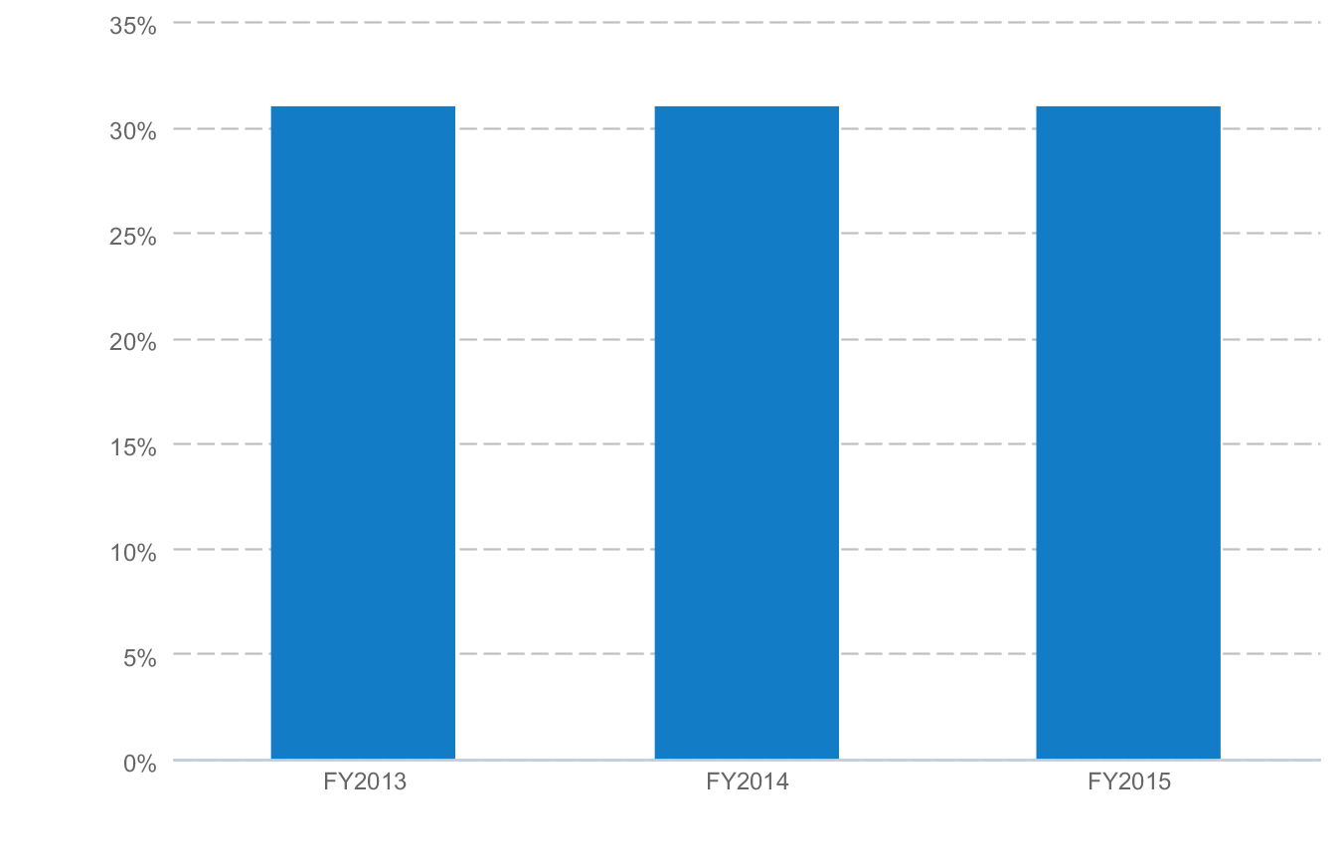

Net Profit (or Loss) by Year
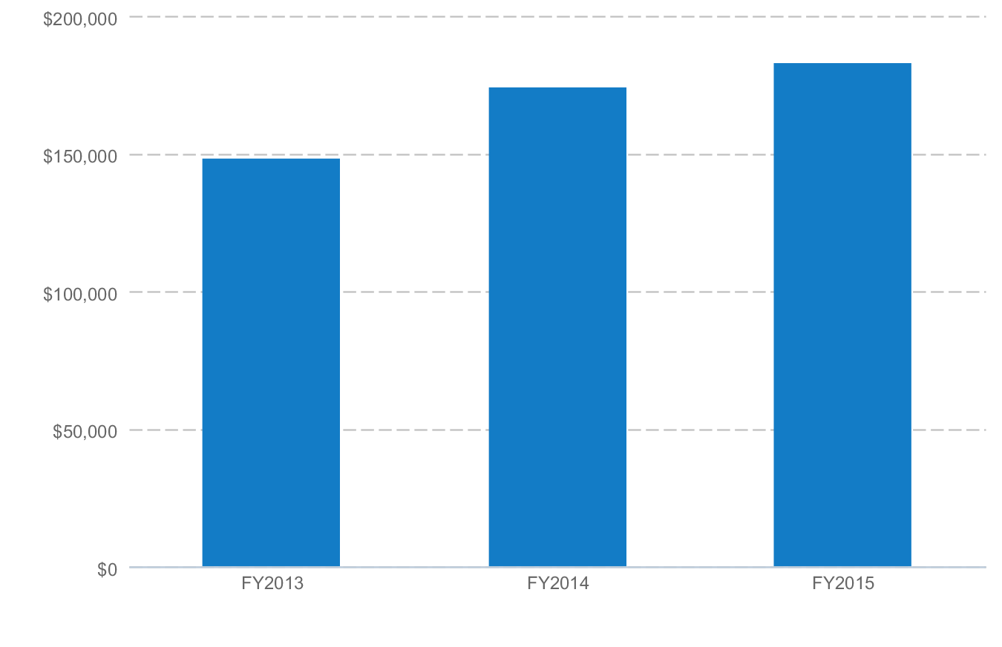

About the Profit and Loss Statement
Month-by-month forecasts for profit and loss are included in the appendix. This is a very realistic forecast as the numbers are based on actual sales figured from Tiger Mart Corp. We only showed a very minimal growth which is usually achieved with very minimal effort in marketing, customer service and proper product availability at the right price.

Appendix

Sales Forecast

Sales Forecast Table (With Monthly Detail)
FY2013 | Nov '12 | Dec '12 | Jan '13 | Feb '13 | Mar '13 | Apr '13 | May '13 | Jun '13 | Jul '13 | Aug '13 | Sep '13 | Oct '13
Sales
Gasoline | $0 | $0 | $0 | $0 | $0 | $0 | $0 | $0 | $0 | $0 | $0 | $0
C-Store | $78,000 | $83,000 | $87,000 | $94,000 | $102,000 | $107,000 | $111,000 | $109,000 | $112,000 | $110,000 | $108,000 | $103,000
Total Sales | $78,000 | $83,000 | $87,000 | $94,000 | $102,000 | $107,000 | $111,000 | $109,000 | $112,000 | $110,000 | $108,000 | $103,000
Direct Cost
Gasoline | $0 | $0 | $0 | $0 | $0 | $0 | $0 | $0 | $0 | $0 | $0 | $0
C-Store | $53,820 | $57,270 | $60,030 | $64,860 | $70,380 | $73,830 | $76,590 | $75,210 | $77,280 | $75,900 | $74,520 | $71,070
Total Direct Cost | $53,820 | $57,270 | $60,030 | $64,860 | $70,380 | $73,830 | $76,590 | $75,210 | $77,280 | $75,900 | $74,520 | $71,070
Gross Margin | $24,180 | $25,730 | $26,970 | $29,140 | $31,620 | $33,170 | $34,410 | $33,790 | $34,720 | $34,100 | $33,480 | $31,930
Gross Margin % | 31% | 31% | 31% | 31% | 31% | 31% | 31% | 31% | 31% | 31% | 31% | 31%

 | FY2013 | FY2014 | FY2015
Sales
Gasoline | $0 | $0 | $0
C-Store | $1,204,000 | $1,310,000 | $1,350,000
Total Sales | $1,204,000 | $1,310,000 | $1,350,000
Direct Cost
Gasoline | $0 | $0 | $0
C-Store | $830,760 | $903,900 | $931,500
Total Direct Cost | $830,760 | $903,900 | $931,500
Gross Margin | $373,240 | $406,100 | $418,500
Gross Margin % | 31% | 31% | 31%

Personnel Plan

Personnel Table (With Monthly Detail)
FY2013 | Nov '12 | Dec '12 | Jan '13 | Feb '13 | Mar '13 | Apr '13 | May '13 | Jun '13 | Jul '13 | Aug '13 | Sep '13 | Oct '13
Store Manager | $2,583 | $2,583 | $2,583 | $2,583 | $2,583 | $2,583 | $2,583 | $2,583 | $2,584 | $2,584 | $2,584 | $2,584
Hourly Employee | $1,344 | $1,344 | $1,344 | $1,344 | $1,344 | $1,344 | $1,344 | $1,344 | $1,344 | $1,344 | $1,344 | $1,344
Hourly Employee | $1,340 | $1,340 | $1,340 | $1,340 | $1,340 | $1,340 | $1,340 | $1,340 | $1,340 | $1,340 | $1,340 | $1,340
Hourly Employee | $1,340 | $1,340 | $1,340 | $1,340 | $1,340 | $1,340 | $1,340 | $1,340 | $1,340 | $1,340 | $1,340 | $1,340
Hourly Employee | $1,650 | $1,650 | $1,650 | $1,650 | $1,650 | $1,650 | $1,650 | $1,650 | $1,650 | $1,650 | $1,650 | $1,650
Total | $8,257 | $8,257 | $8,257 | $8,257 | $8,257 | $8,257 | $8,257 | $8,257 | $8,258 | $8,258 | $8,258 | $8,258

 | FY2013 | FY2014 | FY2015
Store Manager | $31,000 | $31,620 | $32,252
Hourly Employee | $16,128 | $16,608 | $17,112
Hourly Employee | $16,080 | $16,404 | $16,728
Hourly Employee | $16,080 | $16,404 | $16,728
Hourly Employee | $19,800 | $20,196 | $20,604
Total | $99,088 | $101,232 | $103,424

Budget

Budget Table (With Monthly Detail)
FY2013 | Nov '12 | Dec '12 | Jan '13 | Feb '13 | Mar '13 | Apr '13 | May '13 | Jun '13 | Jul '13 | Aug '13 | Sep '13 | Oct '13
Expenses
Salary | $8,257 | $8,257 | $8,257 | $8,257 | $8,257 | $8,257 | $8,257 | $8,257 | $8,258 | $8,258 | $8,258 | $8,258
Employee Related Expenses | $991 | $991 | $991 | $991 | $991 | $991 | $991 | $991 | $991 | $991 | $991 | $991
Marketing & Promotion | $750 | $750 | $750 | $750 | $750 | $750 | $750 | $750 | $750 | $750 | $750 | $750
Mortgage | $3,000 | $3,000 | $3,000 | $3,000 | $3,000 | $3,000 | $3,000 | $3,000 | $3,000 | $3,000 | $3,000 | $3,000
Utilities | $2,800 | $2,800 | $2,800 | $2,800 | $2,800 | $2,800 | $2,800 | $2,800 | $2,800 | $2,800 | $2,800 | $2,800
Office Supplies | $75 | $75 | $75 | $75 | $75 | $75 | $75 | $75 | $75 | $75 | $75 | $75
Insurance | $650 | $650 | $650 | $650 | $650 | $650 | $650 | $650 | $650 | $650 | $650 | $650
Total Expenses | $16,523 | $16,523 | $16,523 | $16,523 | $16,523 | $16,523 | $16,523 | $16,523 | $16,524 | $16,524 | $16,524 | $16,524

 | FY2013 | FY2014 | FY2015
Expenses
Salary | $99,088 | $101,232 | $103,424
Employee Related Expenses | $11,892 | $12,146 | $12,402
Marketing & Promotion | $9,000 | $9,000 | $9,000
Mortgage | $36,000 | $36,000 | $36,000
Utilities | $33,600 | $33,600 | $33,600
Office Supplies | $900 | $900 | $900
Insurance | $7,800 | $7,800 | $7,800
Total Expenses | $198,280 | $200,678 | $203,126

Profit and Loss Statement

Profit and Loss Statement (With Monthly Detail)
FY2013 | Nov '12 | Dec '12 | Jan '13 | Feb '13 | Mar '13 | Apr '13 | May '13 | Jun '13 | Jul '13 | Aug '13 | Sep '13 | Oct '13
Revenue | $78,000 | $83,000 | $87,000 | $94,000 | $102,000 | $107,000 | $111,000 | $109,000 | $112,000 | $110,000 | $108,000 | $103,000
Direct Cost | $53,820 | $57,270 | $60,030 | $64,860 | $70,380 | $73,830 | $76,590 | $75,210 | $77,280 | $75,900 | $74,520 | $71,070
Gross Margin | $24,180 | $25,730 | $26,970 | $29,140 | $31,620 | $33,170 | $34,410 | $33,790 | $34,720 | $34,100 | $33,480 | $31,930
Gross Margin % | 31% | 31% | 31% | 31% | 31% | 31% | 31% | 31% | 31% | 31% | 31% | 31%
Expenses
Salary | $8,257 | $8,257 | $8,257 | $8,257 | $8,257 | $8,257 | $8,257 | $8,257 | $8,258 | $8,258 | $8,258 | $8,258
Employee Related Expenses | $991 | $991 | $991 | $991 | $991 | $991 | $991 | $991 | $991 | $991 | $991 | $991
Marketing & Promotion | $750 | $750 | $750 | $750 | $750 | $750 | $750 | $750 | $750 | $750 | $750 | $750
Mortgage | $3,000 | $3,000 | $3,000 | $3,000 | $3,000 | $3,000 | $3,000 | $3,000 | $3,000 | $3,000 | $3,000 | $3,000
Utilities | $2,800 | $2,800 | $2,800 | $2,800 | $2,800 | $2,800 | $2,800 | $2,800 | $2,800 | $2,800 | $2,800 | $2,800
Office Supplies | $75 | $75 | $75 | $75 | $75 | $75 | $75 | $75 | $75 | $75 | $75 | $75
Insurance | $650 | $650 | $650 | $650 | $650 | $650 | $650 | $650 | $650 | $650 | $650 | $650
Total Expenses | $16,523 | $16,523 | $16,523 | $16,523 | $16,523 | $16,523 | $16,523 | $16,523 | $16,524 | $16,524 | $16,524 | $16,524
Operating Income | $7,657 | $9,207 | $10,447 | $12,617 | $15,097 | $16,647 | $17,887 | $17,267 | $18,196 | $17,576 | $16,956 | $15,406
Income Taxes | $1,149 | $1,381 | $1,567 | $1,893 | $2,264 | $2,497 | $2,683 | $2,590 | $2,729 | $2,636 | $2,544 | $2,311
Net Profit | $6,508 | $7,826 | $8,880 | $10,724 | $12,833 | $14,150 | $15,204 | $14,677 | $15,467 | $14,940 | $14,412 | $13,095
Net Profit / Sales | 8% | 9% | 10% | 11% | 13% | 13% | 14% | 13% | 14% | 14% | 13% | 13%

 | FY2013 | FY2014 | FY2015
Revenue | $1,204,000 | $1,310,000 | $1,350,000
Direct Cost | $830,760 | $903,900 | $931,500
Gross Margin | $373,240 | $406,100 | $418,500
Gross Margin % | 31% | 31% | 31%
Expenses
Salary | $99,088 | $101,232 | $103,424
Employee Related Expenses | $11,892 | $12,146 | $12,402
Marketing & Promotion | $9,000 | $9,000 | $9,000
Mortgage | $36,000 | $36,000 | $36,000
Utilities | $33,600 | $33,600 | $33,600
Office Supplies | $900 | $900 | $900
Insurance | $7,800 | $7,800 | $7,800
Total Expenses | $198,280 | $200,678 | $203,126
Operating Income | $174,960 | $205,422 | $215,374
Income Taxes | $26,244 | $30,813 | $32,306
Net Profit | $148,716 | $174,609 | $183,068
Net Profit / Sales | 12% | 13% | 14%

